Chapter 3, Solution 67

Consider the circuit below.

V₂
10 Ω
5Ω
10 A
3 V_{o}
V₁
2 Ω
4 Ω
5 A

V₃

+ V_{o} -

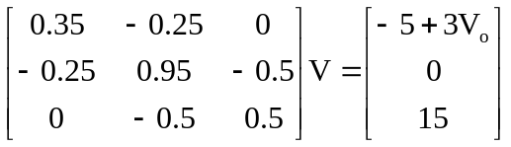

Since we actually have four unknowns and only three equations, we need a constraint equation.

V_{o} = V₂ – V₃

Substituting this back into the matrix equation, the first equation becomes,

0.35V₁ – 3.25V₂ + 3V₃ = –5

This now results in the following matrix equation,

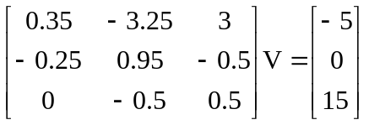

Now we can use MATLAB to solve for V.

>> Y=[0.35,-3.25,3;-0.25,0.95,-0.5;0,-0.5,0.5]

Y =

0.3500 -3.2500 3.0000
-0.2500 0.9500 -0.5000
0 -0.5000 0.5000

>> I=[–5,0,15]'

I =

–5
0
15

>> V=inv(Y)*I

V =

–410.5262
–194.7368
–164.7368

V_{o} = V₂ – V₃ = –77.89 + 65.89 = –30 V.

Let us now do a quick check at node 1.

–3(–30) + 0.1(–410.5) + 0.25(–410.5+194.74) + 5 =
90–41.05–102.62+48.68+5 = 0.01; essentially zero considering the accuracy we are using. The answer checks.

